
Amazon Interview Worksheet
CUSTOMER OBSESSION
Definition and Indicators
Customer Obsession: Leaders start with the customer and work backwards. They work vigorously to earn and keep customer trust. Although leaders pay attention to competitors, they obsess over customers.
What this looks like in Practice
As a people manager do you… | As an individual contributor do you…
- Know your customer’s needs and wants?
- Anticipate your customer’s needs?
- Honestly pursue customer feedback, not just solicit for compliments?
- “WOW” your customers?
- Know what would be better than what your customer is even imagining?
- Ask, “Is what I’m working on helping my customer?”
- Remove non-value steps?
- Listen for what your customer wants, before/instead of telling them what they need?

Customer Obsession - Suggested Behavioral Interview Questions
For each question you choose, use a separate STAR Worksheet
Questions for (Manager) in parentheses

- Give me an example of a time you used customer feedback to drive improvement or innovation. What was the situation and what action did you take?
- Give me an example of your most difficult customer interaction and how you worked through it. What was the outcome?
- Tell me about a time a customer wanted one thing, but you felt they needed something else. How did you approach the situation, what were your actions and what was the end result?
- Tell me about a time when you went above and beyond the call of duty for a customer. Why did you take the action you did? What was the outcome?
- Most of us at one time or another have felt frustrated or impatient when dealing with customers. Can you tell us about a time when you felt this way and how you dealt with it? When do you think it’s appropriate to push back or say no to an unreasonable customer request?
- Can you give me an example of when you’ve been able to see around the corner to meet a customer need or delight a customer with a solution or product they didn’t yet know they needed/wanted?
- To try to meet the high expectations of our customers, we sometimes promise more than we can deliver. Tell me about a time when you overcommitted yourself or your company. How did you resolve the issue?
- Tell me about a time when you had to balance the needs of the customer vs. the needs of the business. How did you manage this situation?
- In your opinion, what is the most effective way to evaluate the quality of your product or service to your internal /external customer? Give an example of a time when you used these measures to make a decision. (Manager)
- What changes have you implemented in your current department to meet the needs of your customers? What has been the result? (Manager)

STAR WORKSHEET
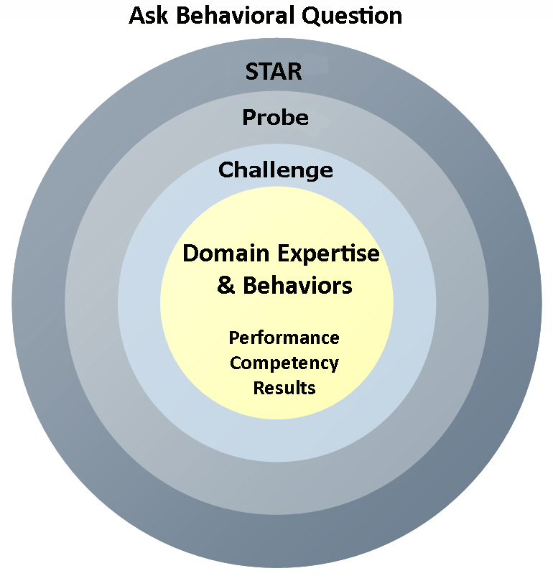
Your Behavioral Question:___________________________________________________________________Leadership Principle:_________________

- Choose behavioral question that provoke specific examples or stories for your assigned Leadership Principle(s).
- Process the example using STAR. Stories have beginnings (Situation/Task), middles (Actions) and ends (Results).
- Once you have established the story, PROBE to dive deeper on your assigned competency (Leadership Principle), get clarity or pursue a concern.
- If appropriate, CHALLENGE the candidate’s statements, decisions or thought process.
S  T | SITUATION/TASK - Describe the situation/task you faced and the context of the story  Answers the questions: where did this occur, when did it happen, why is it important?  Probing Questions:  - Why is this important? What was the goal?  - What was the initial scope of the project? What were the challenges?  - What were the risks and potential consequences if nothing happened?  Challenge Questions:  - Why did you choose this story to illustrate a xyz accomplishment?  - What other stories can you think of that demonstrate.. xyz?  - Could you come up with an example that is more recent? | Notes
A | ACTION - What actions did you take?  Answers the questions: what did you personally own, how did you do it, who else was involved?  Probing Questions:  - Deep probe functional expertise and/or assigned core competency.  - Were you the key driver or project owner?  - What was your biggest contribution? What unique value did you bring?  - What were the most significant obstacles you faced? How did you overcome them?  Challenge Questions:  - What did you do specifically versus the team?  - How did you set priorities…deal with xyz problem… or get manager buy-in?  - What decisions did you challenge? Why? How did you influence the right outcome?
R | RESULTS - How did you measure success for this project? What results did you achieve?  $ Cost savings, revenue generation  # Quantify to understand volume, size, scale  % Percentage change, year over year improvements  Time to market, implementation time, time savings  Impact on the customer, the team  δ Quality improvements  Probing Questions:  - Why did you choose to focus on these results? What other results were important?  - You mentioned revenue, what percentage change is that year over year?  - What trade-offs did you have to make to achieve this? (quality, cost, time)  - I’m concerned about… (the time it took, the volume, the customer impact), tell me more…  Challenge Questions:  - What were the lessons learned? What would you have done differently?  - How would you implement this at Amazon?  - How did these results compare to your actual goals? (refer back to goal stated in Situation)

